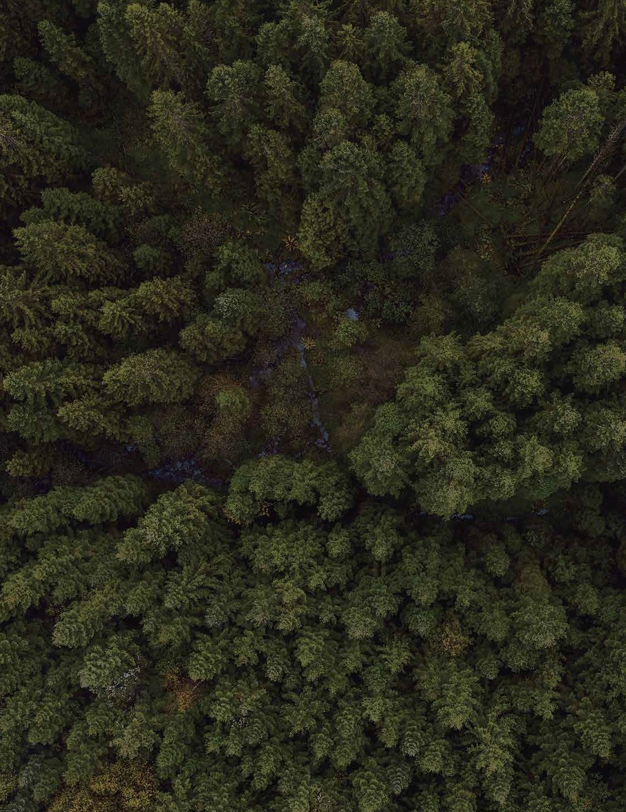

Farther.   
Smarter.

More.

2023 Season - Interim Report

February 7, 2024

We are a Rapid Reforestation Technology Company

Trevor Grant Founder and CEO [trevor@kidrone.org](mailto:trevor@kidrone.org)

# INTRODUCTION

# On October 25th, 2023 KiDrone conducted field demonstrations by aerially dispersing encapsulated seed over approximately 11 ha of previously harvested land on cutblock CBK0035 PU1 and 9.5 ha of previously harvested land on cutblock CBK0035 PU2. Additionally, aerial dispersal of encapsulated seed occurred over approximately 8.5ha of previously harvested land on cutblock CBK0036, approximately 5 ha of previously harvested land on cutblock 21106, and approximately 20 ha of previously harvested land on cutblock 08081. These demonstrations will hereafter be referred to as Fall 2023 field tests.

# On February 3rd, 2024, KiDrone conducted further field demonstrations by aerially dispersing encapsulated seed over approximately 10.6 ha of previously harvested land on cutblock CBK0035 PU1 and 9.5 ha of previously harvested land on cutblock CBK0035 PU2. Additionally, aerial dispersal of encapsulated seed occurred over approximately 8.4 ha of previously harvested land on cutblock CBK0036, approximately 5 ha of previously harvested land on cutblock 21106, and approximately 20 ha of previously harvested land on cutblock 08081. These demonstrations will hereafter be referred to as Winter 2024 field tests.

The field demonstrations took place in partnership with Canfor. KiDrone subcontracted the direct seeding for the field demonstrations to a helicopter-based dispersal service provider (the “Subcontractor”).

Canfor provided their own seed for their respective field test blocks, which was then encapsulated prior to dispersal by the Northern Alberta Institute of Technology (“**NAIT**”) using their proprietary formulation with an enhanced inclusion of 5% nitrogen to combat perceived soil deficiencies at many of the sites.Seed mixes of Spruce Hybrid (Sx), Lodgepole Pine (Pli), Douglas Fir (Fdi) and Western Larch (Lw) were distributed on sites CBK0035 PU1 and CBK0035 PU2. On site CBK0036, seed mixes of Douglas Fir (Fdi) and Western Larch (Lw) were distributed. At the Fort St. John sites, 21106 and 8081, Lodgepole Pine (Pli) and Spruce Hybrid (Sx) were distributed.

# Objectives

# The Objectives of the Fall 2023 and Winter 2024 field tests are as follows:

# to demonstrate the germination and survival rates of aerially dispersed encapsulated seed;

# to assess whether the enhanced encapsulation mix manufactured by NAIT provides any significant advantages to the growth and establishment of these tree species by comparing germination and early survival between encapsulated seeds and non-encapsulated seeds of the four species (Pli, Sx, Fdi, Lw); and

# 

# to assess whether the time of seeding and pre-stratification of seeds are factors that significantly impact seed germination and survival.

# 3.0 AERIAL DIRECT SEEDING – CBK0035 PU1

# 3.1 Site Conditions

# This site is located in Cranbrook in the MSdw (Montane Spruce, Dry Warm) biogeoclimatic unit. Gross block area in CBK0035 PU1 is 47.5 ha while the net area to reforest is 41 ha. The trial area is shaded purple in the figure below. In Fall 2023 demonstrations, 11 ha of aerial seeding was applied. In Winter 2024 demonstrations, 10.6 ha of aerial seeding was applied.

# The prescription applied to this block for both the Fall and Winter applications was 30% Pli, 30% Fdi, 30% Lw and 20% Sx.

# Block CP0035 PU1 Direct Seeding Trial Location (purple)

# Flight Data

Seed dispersal commenced for the Fall application at CP0035 at roughly 10:00 am and outside temperatures were roughly -10ᵒC with a light breeze (2-3 knots) and a light dusting of snow (less than 1 centimeter). A total of 4,218 grams of encapsulated seed was dispersed giving a seeding density of 0.499 seeds per metres square. The helicopter flight path and active seeding drop locations are illustrated in the map below.

The seed dispersal for the Winter application for CP0035 PU1 commenced at roughly 10:20 am and outside temperatures were roughly -2ᵒC with light, variable wind out of the south and significant snow coverage on the ground. A total of 4,088 grams of encapsulated seed was dispersed giving a seeding density of 1.02 seeds per metres square. The helicopter flight path and active seeding drop locations are illustrated in the map below.

# 4.0 AERIAL DIRECT SEEDING – CBK0035 PU2

# 4.1 Site Conditions

# The site is located in Cranbrook in the MSdw biogeoclimatic unit Gross block area in CBK0035 PU2 is 47.5 ha while the net area to reforest is 41 ha. The trial area is shaded pink in the figure below. In Fall 2023, 9.5 ha of aerial seeding was applied. In Winter 2024, 9.5 ha of aerial seeding was applied.

# The prescription applied to this block for both the Fall and Winter applications was 40% Fdi, 40% Lw and 20% Pli.

# Block CP0035 PU1 Direct Seeding Trial Location (pink)

# 4.2 Flight Data

The Fall 2023 seed dispersal for CP0035 PU2 commenced at roughly 10:20 am and outside temperatures were roughly -10ᵒC with a light breeze (2-3 knots) and a light dusting of snow (less than 1 centimeter). A total of 3,201 grams of encapsulated seed was dispersed giving a seeding density of 0.557 seeds per metres square. The helicopter flight path and active seeding drop locations are illustrated in the map below.

The Winter seed dispersal for CP0035 PU2 commenced at roughly 9:20 am and outside temperatures were roughly -2ᵒC with light, variable wind out of the south and significant snow coverage on the ground. A total of 3,165 grams of encapsulated seed was dispersed giving a seeding density of 1.01 seeds per metres square. The helicopter flight path and active seeding drop locations are illustrated in the map below.

# 5.0 AERIAL DIRECT SEEDING – CP0036

# 5.1 Site Conditions

# The site is located in Cranbrook in the PP (Ponderosa Pine) biogeoclimatic unit. Gross block area in CBK0036 is 20 ha while the net area to reforest is 17 ha. The trial area is outlined in yellow in the figure below. In Fall 2023, 8.5 ha of aerial seeding was applied. In Winter 2024, 8.4 ha of aerial seeding was applied.

# The prescription applied to this block for both the Fall and Winter applications was 50% Fdi, 50% Lw.

# Block CP0036 Direct Seeding Trial Location (purple)

# 5.2 Flight Data

The seed dispersal for the Fall application of CP0036 commenced at roughly 9:30 am and outside temperatures were roughly -10ᵒC with a light breeze (2-3 knots) and a light dusting of snow (less than 1 centimeter). A total of 3,432 grams of encapsulated seed was dispersed giving a seeding density of 0.739 seeds per metres square. The helicopter flight path and active seeding drop locations are illustrated in the map below.

The Winter seed dispersal at CP0036 commenced at roughly 9:00 am and outside temperatures were roughly -2ᵒC with light, variable wind out of the south and significant snow coverage on the ground. A total of 3,310 grams of encapsulated seed was dispersed giving a seeding density of 1.01 seeds per metres square. The helicopter flight path and active seeding drop locations are illustrated in the map below.

# 6.0 AERIAL DIRECT SEEDING – 21106

# 6.1 Site Conditions

# The site is located in Fort St. John in the SBSmc2 biogeoclimatic unit. Gross block area in 21106 is 101.7 ha while the net area to reforest is 84.5 ha. The trial area is outlined in yellow in the figure below. In Fall 2023, 5 ha of aerial seeding was applied. In Winter 2024, 5 ha of aerial seeding was applied.

# The prescription applied to this block for both the Fall and Winter applications was 80% Pli and 20% Sx.

# Block 21106 Direct Seeding Trial Location (yellow highlight)

# 6.2 Flight Data

The Fall seed dispersal commenced at roughly 11:00 am and outside temperatures were roughly 10ᵒC with a light breeze (2-3 knots) out of the south. A total of 1,696 grams of encapsulated seed was dispersed giving a seeding density of 8.926 seeds per metres square. The helicopter flight path and active seeding drop locations are illustrated in the map below.

The Winter seed dispersal for 21106 commenced at roughly 9:55 am and outside temperatures were roughly -18ᵒC with 10 km/hour winds out of the south and significant snow coverage on the ground. A total of 1,626 grams of encapsulated seed was dispersed giving a seeding density of 1.02 seeds per metres square. The helicopter flight path and active seeding drop locations are illustrated in the map below.

# 7.0 AERIAL DIRECT SEEDING – 08081

# 7.1 Site Conditions

# The site is located in Fort St. John in the SBSmc2 biogeoclimatic unit, Gross block area in 08081 is 124.6 ha while the net area to reforest is 109 ha. The trial area is outlined in yellow in the figure below. In Fall 2023, 20 ha of aerial seeding was applied. In Winter 2024, 20 ha of aerial seeding was applied.

# The prescription applied to this block for both the Fall and Winter applications was 80% Pli and 20% Sx.

# 

# Block 08081 Direct Seeding Trial Location (yellow highlight)

# 7.2 Flight Data

The Fall seed dispersal for 08081 commenced at roughly 11:30 am and outside temperatures were 10ᵒC with a light breeze (2-3 knots) out of the south. A total of 6,416 grams of encapsulated seed was dispersed giving a seeding density of 8.44 seeds per metres square. The helicopter flight path and active seeding drop locations are illustrated in the map below.

The Winter seed dispersal commenced at roughly 11:10 am and outside temperatures were -20ᵒC with occasional gusts of wind (3-5 km/hour) from the south and significant snow coverage on the ground. A total of 6,429 grams of encapsulated seed was dispersed giving a seeding density of 1.01 seeds per metres square. The helicopter flight path and active seeding drop locations are illustrated in the map below.

1. **PLANS FOR CONTINUED MONITORING**

Until the follow-up monitoring at CBK0035 PU1 and PU2, CBK0035, 21106, and 08081 sites can be conducted, information on the germination and survival rates cannot be ascertained.  There may be preliminary data available after the Fall 2023 site visits, but KiDrone is optimistic that future site visits will yield useful data to evaluate the success of these demonstrations, as well as insight into the encasement technology as a whole.

KiDrone anticipates undertaking a regeneration survey using the standard silviculture survey procedures described in the 2022 Silviculture Survey Procedure Manual with careful attention to distinguishing between naturally established seedings and those that were aerially seeded, and careful evaluation of germinants.  

# Follow-up monitoring is expected to occur in April or May 2024, and again in fall 2024 following the growing season. At these times, a thorough examination of the sites will be undertaken and germination data collected Site visits in 2024 and onwards will record any new germinations and survival of seeds that had previously germinated.

1. **CONCLUSIONS RE SEED ENCAPSULATION AND SEEDING DENSITIES**

The target application rate of 1 seed per square meter was achieved within a very tight variance for each of the Winter applications. The numbers for the Fall application were far less consistent. The issue we had run into in hindsight was the nitrogen enrichment process we included in our second-generation encapsulation formulation caused a large variance in encapsulation size from our standard expectations. This unfortunately impacted the Fall dispersals causing a wide variance between the encapsulated seed size from what our dispersal systems was calibrated to. The issue appears to have been specifically related to Douglas Fir.

The issue was recognized when we examined the dispersal data post the Fall applications and the encapsulation process was refined an ultimately rectified with our encapsulation subcontractor, NAIT, and the issue as noted immediately above was remediated for the Winter applications.

1. **FURTHER INFORMATION**

For further information on this exciting initiative, please contact Trevor Grant at:

Cell phone: +1.416.315.8906

Email: [trevor@kidrone.org](mailto:trevor@kidrone.org)

Website: <https://www.kidrone.org/>